Introduction

Australian freelance civil/structural engineer with extensive experience. Based in Spain with availability for either short or long-term assignments. With particular interest in:

* Management of construction document preparation from design development, through detailed design to as-built phases; drawings, specifications, maintenance manuals etc.;
* Representation of consultant at design/site/project management meetings;
* Assessment and evaluation of claims to establish responsibility, cause, effect and damage, to assist in mediation.

Résumé

|  |  |  |  |  |
| --- | --- | --- | --- | --- |
| Profile |  | Experience |  | Profession |
| Extensive construction industry experience in the fields of civil and structural engineering, covering both building structures and, more recently, bridge projects.  Work experience in Australia, England and Spain. | * Broad range of experience in design, site supervision, independent checking and project management. * Structural design of building projects in reinforced concrete, structural steelwork, timber, and masonry. * Civil Engineering design of paved areas and drainage in housing developments. * Quantities estimating, structural surveys and appraisals of existing buildings, reports, method statements, specifications etc. * Contractual, technical and financial evaluation of construction claims. |  | Structural/Civil Engineer |
|  | Nationality | Languages |
|  | Australian |Fluent in Spanish |
|  | Qualifications |
|  | BE (Civil) University of Melbourne. 1982 |
|  | Online Computer Science Courses Harvard University |
|  | * CS50 Web: *Web Programming with Python and JavaScript;* * CS50 AI: *Introduction to Artificial Intelligence with Python*; * CS50x: *Introduction to Computer Science*.   Professional Associations |
|  | Corporate Member Institution of Structural Engineers (MIStructE)  Graduate Member Institution of Civil Engineers (GMICE) |
| Experience 2006 to present | | | | |
| **Evaluation of contract claims**  Assessment of the contractual, technical and financial position of construction claims brought against Eptisa including evaluation of experts' reports and insurance coverage. Attendance at mediation to assist in the negotiated resolution of disputes.  **Mersey Gateway Project**  **Deputy Project Manager Landside Structures.** Project manager for Eptisa whose design responsibilities covered all retaining walls, drainage for the entire project including the Main Bridge, geotechnical design and sub-structure design for the Astmoor & Bridgewater Viaduct. Responsible for the supervision of production and submission of drawings and reports, including quality control. Attended weekly design coordination meetings as well as monthly DJV Board meetings.  **N25 New Ross Bypass**  **Project Manager CAT III check** including Barrow Crossing. Responsible for overseeing the independent checking (category 3) and acceptance of structural drawings and geotechnical reports as well as attending client coordination meetings.  **New Europe Bridge**  **Management of production of Working Drawings and also Design Site Representativ**e for the New Europe Bridge (Vidin–Calafat Bridge, Bulgaria). Responsible for developing the design general arrangement drawings for the entire project into working drawings. These included the river crossing and approach as well as the railway bridge and the drainage design for both structures. Design Site Representative and attended monthly site design coordination meetings between designers, client and checking engineers. | | | | |

Employment history

|  |  |
| --- | --- |
| Since Sep-13 | **Eptisa Servicios de Ingenieria, SL.**  Project Manager CAT III Check **N25 New Ross Bypass**. Contact value €230m.  Deputy Project Manager Landside Structures, **Mersey Gateway Project**. Contact value £550m. |
| Jun 08- Jun 13 | **FCC Construccion SA.**  Responsible for producing the Working Drawings and Design Site Representative for the New Europe Bridge (Vidin-Calafat, Bulgaria). Contract value €235m. |
| Apr-06- Jun 08  May 04- Nov 05 | **Dragados SA.**  Quality Control Technician Torre Cepsa. Contract value €82m.  **Oproler Madrid SA.**  Site manager refurbishment of 19,000m2 of office space in two buildings for Ericsson Spain. Contract value €1.7m |
| Sep 02- Feb 04 | **Ross & Partners, London /Fitzpatrick Contractors, London.**  Resident Engineer Gibraltar General Hospital. Contract value £30m. |
| Feb 00- Jul 02 | **Pondio Ingenieros, Madrid.** Design engineer. |
| Sep 97- Aug 99 | **Ross & Partners, London.** Design Engineer. |
| May 91- Sep 97 | **John E. Foster & Partners, London.** Design Engineer/Resident Engineer. |
| Aug 90- Feb 91 | **Ross & Partners, London.** Design Engineer. |
| Mar 90- Aug 90 | **Delta Demolitions, Melbourne.** Site foreman. |
| Dec 88- Mar 90 | **P & S Kubale Ltd, Melbourne.** Site leading hand. |
| Jan 88- Dec 88 | **Zafiris Constructions, Melbourne.** Cost estimator. |
| May 87- Dec 87 | **Ross & Partners, London.** Design Engineer. |
| Jun 86- Mar 87 | **Reviresco Contracting, London.** Site leading hand. |
| Dec 85- May 86 | **P & S Kubale Ltd, Melbourne.** Site leading hand. |
| May 85- Nov 85 | **Ross & Partners, London.** Design Engineer. |
| Sep 83- Nov 84 | **P. Berger & Associates, Melbourne.** Design Engineer. |
| Jan 83-Aug 83 | **Tech Builders, Melbourne.** Site leading hand. |

Experience

Eptisa

Mersey Gateway Project: **Deputy Project Manager Landside Structures**

N25 New Ross Bypass: **Project Manage CAT III check**.

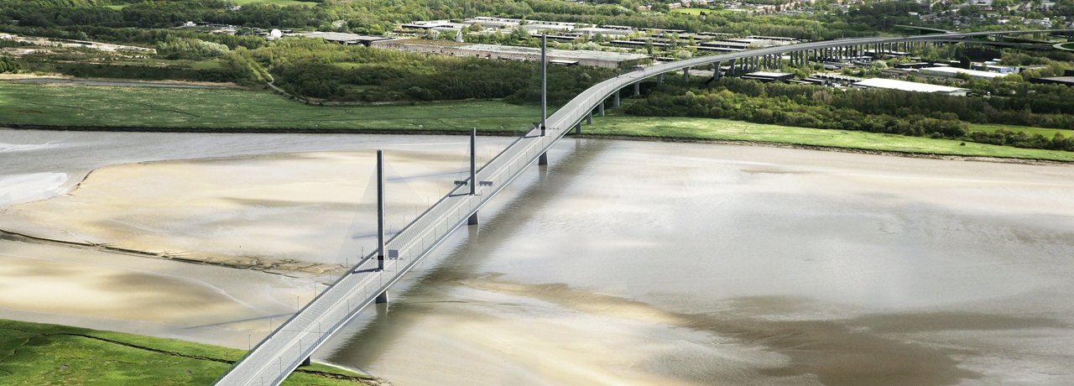

Mersey Gateway Project: Main Bridge

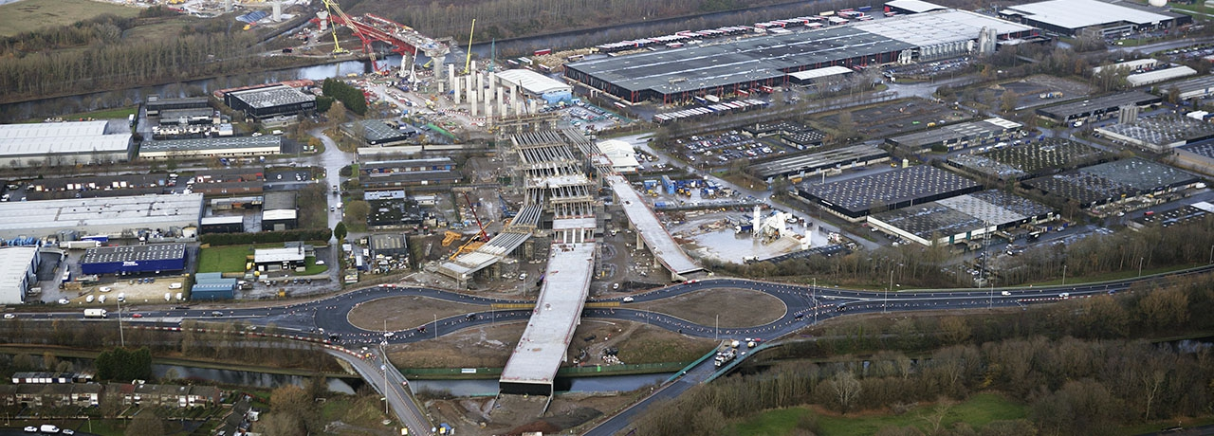

Mersey Gateway Project: Astmoor & Bridgewater Viaduct

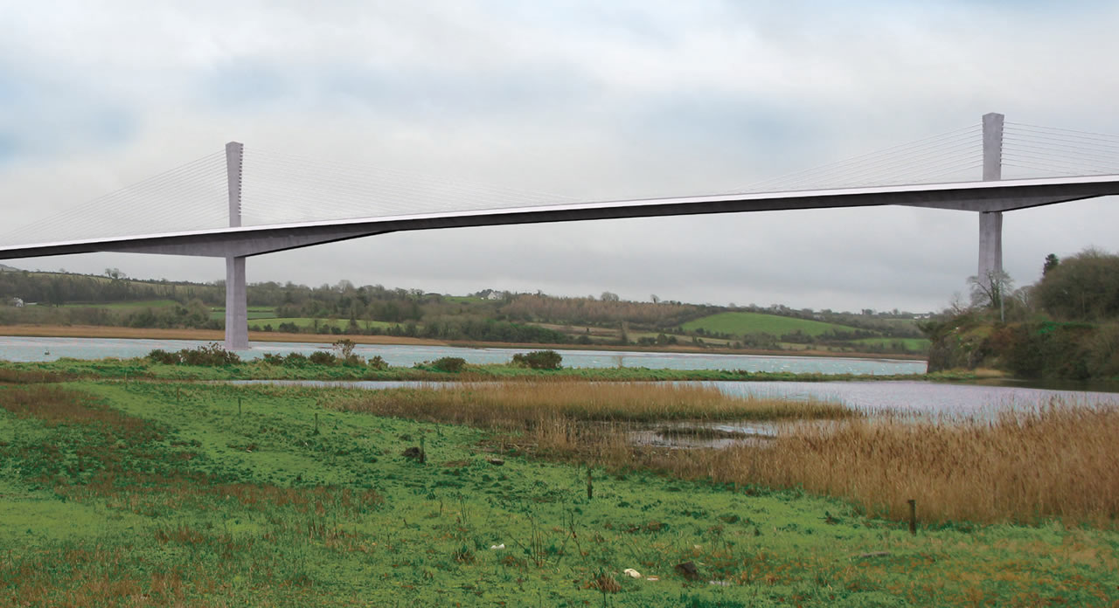

N25 New Ross Bypass: Barrow Crossing

FCC CONSTRUCCIÓN

**In charge of production of Working Drawings and also Design Site Representativ**e for the New Europe Bridge (Vidin–Calafat Bridge,Bulgaria). Contract value 235M€.

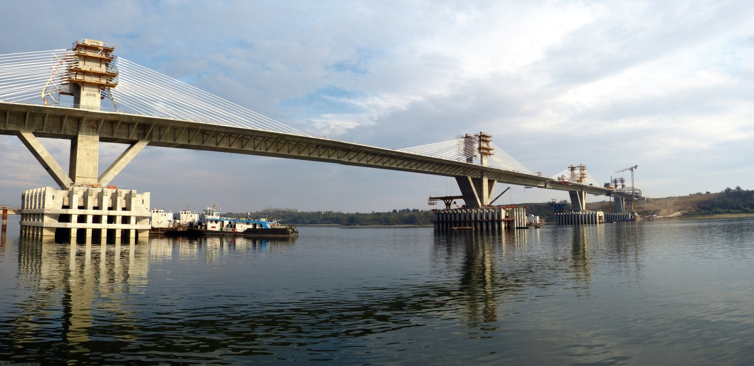

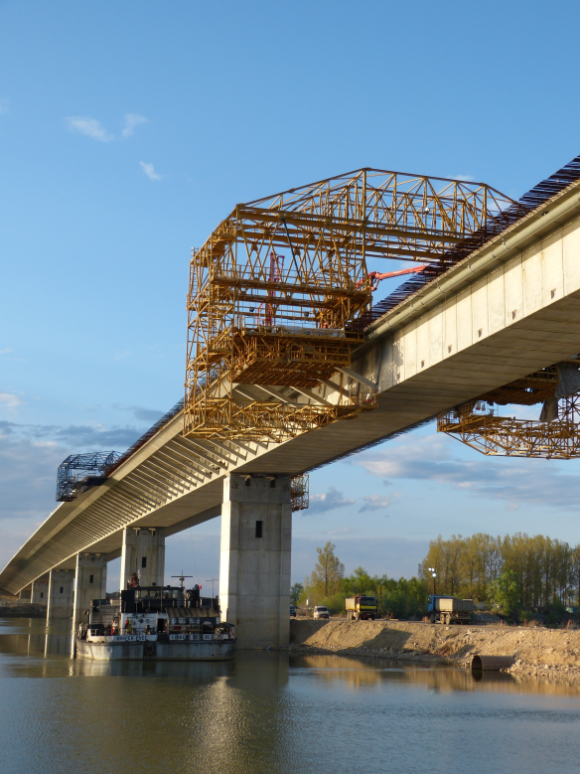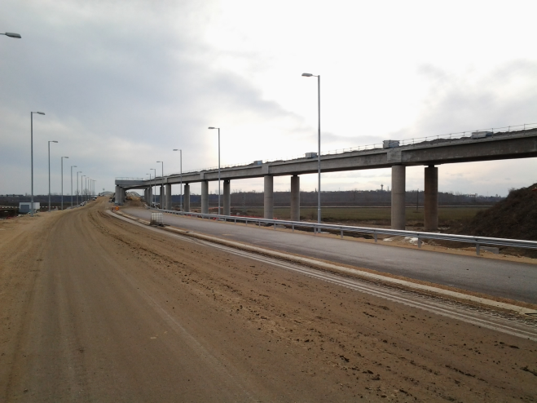

New Europe Bridge

Responsible for developing the Definitive Design drawings into Working Drawings for construction, for all the bridge structural elements: Piling, Pile Caps and Vessel Impact Protection, Piers, Deck, Abutments, etc. Drainage, M&E, Bank Stabilization and Scour Protection.

Resident Engineer and Design Site Representative at the monthly site progress meetings.

DRAGADOS SA

**Quality Control Technician** on250mTorre Cepsa**.** Contract value €82M.

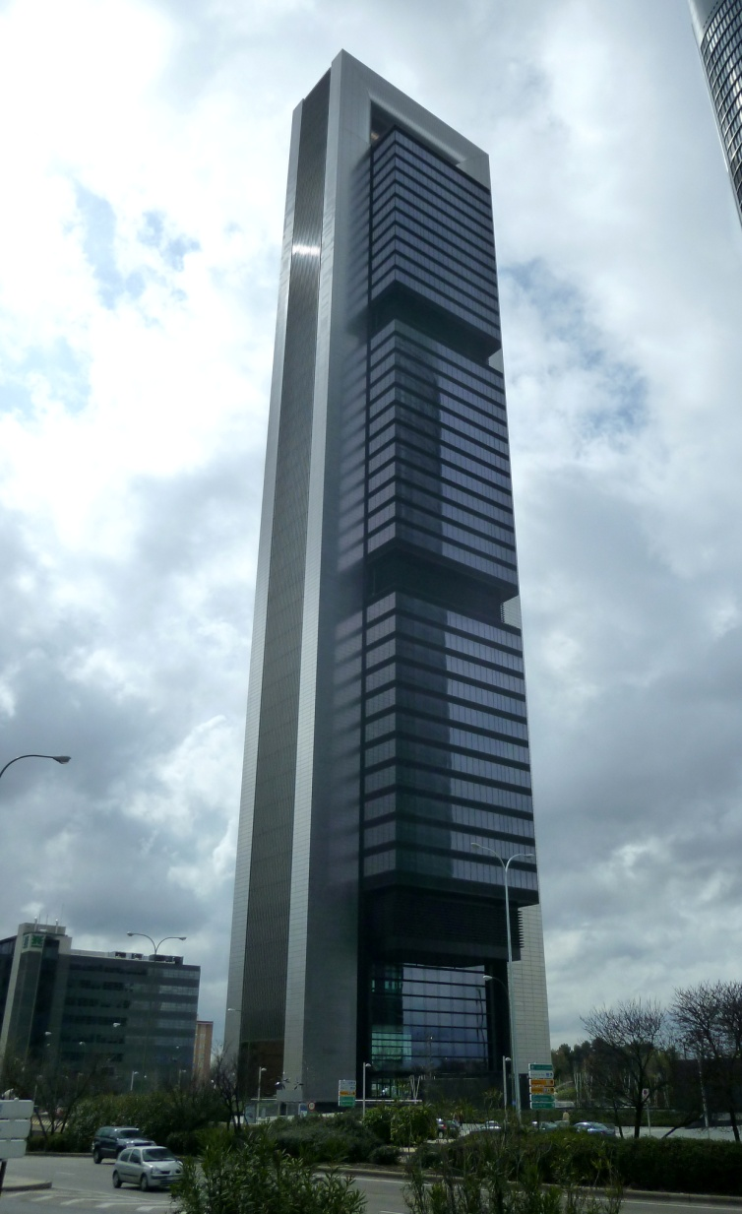

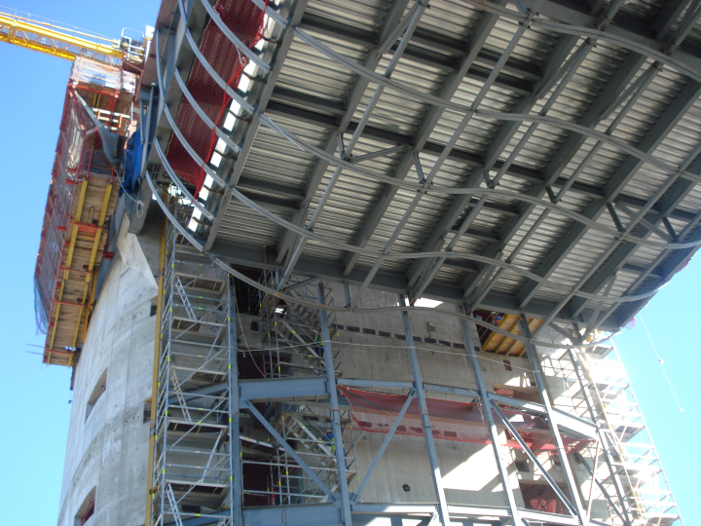

Torre Cepsa

Responsible for on-site quality control checking of reception of materials and execution of reinforced and prestressed concrete structures and concrete-steel composite slabs.

OPROLER MADRID SA

**Site Manager** on refurbishment of 19,000m2 of office space in two buildings for Ericsson Spain. Contract value €1.7m.

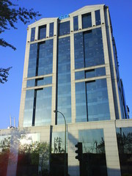

Ericsson Mendez Alvaro

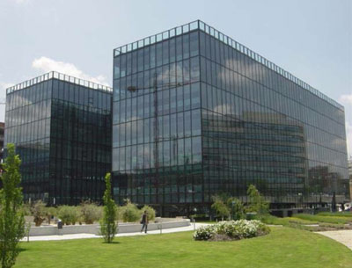

Ericsson Via de Los Poblados

ROSS AND PARTNERS, LONDON

**Resident Engineer** Gibraltar General Hospital (Gibraltar). Contract value £30M.

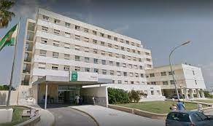

Gibraltar General Hospital

Project involved modifying an existing concrete load bearing wall office complex; drilling and cutting new doors and access for services, also installing new steel framed roof structures and elevated steel walkways between existing buildings.

**Design Engineer**.

Produced design calculations for a vast array of projects in steel, in-situ and precast concrete, timber and load bearing masonry. New build and renovations. Residential, commercial, hospitals, laboratories, and offices.

Preparation of structural surveys and appraisals of existing buildings, reports etc.

Projects included:

|  |  |
| --- | --- |
| **Hospital extension, Bury St Edmunds** | Client: Nuffield Hospitals |
| **Renovation of over 30no. premises Carnaby Estate, Soho, London** | Client: Shaftesbury PLC |
| **Feasibility study Technical Building C, Heathrow Airport** | Client: British Airways |
| **Steelwork framed laboratory, Dartford**  **Steelwork framed laboratory, Ware** | Client: GlaxoWellcome  Client: GlaxoWellcome |
| **Modifications Headquarters Barclays Bank, Poole** | Client: Barclays Bank |
| **BP Headquarters, Hemel Hempstead** | Client: BP |
|  |  |

PONDIO INGENIEROS, MADRID

**Design Engineer**.

Produced design calculations in reinforced concrete for various types of projects including:

|  |  |
| --- | --- |
| **Santiago-Ourense Motorway** | Client: ICEASA |
| **False tunnel Ciudad de la Cultura, Galicia** | Architect: Eisenman Architects |
| **Endesa headquaters** | Client: Prointec |
| **Tenerife Airport North Terminal** | Client: Ferrodarias UTE |
| **Parador Lerma** | Client: Constructora Hispanica |
| **Sporting complex C.A.R.D Sierra Nevada** | Architect: D. Benito Barbadillo de la Fuente |
| **Industrial showrooms, San Sebastián de los Reyes** | Architect: D. Manuel Izquierdo |
| **A.V.E train station Zaragoza** | Client: D. Carlos Ferrater |
| **Repsol Technology Centre, Mostoles** | Client: Proes y Typsa |
| **Apartment block, San Sebastian de los Reyes** | Architect: D. Manuel Izquierdo |
| **Health Centre Benitez, Ceuta** | Architect: D. Gonzalo Cabanillas |
| **Office complex, Las Rozas** | Client: Alatec |
| **Industrial warehouse, Villaverde** | Client: FCC |
| **Offices and retail, San Sebastian de los Reyes** | Client: Inbisa Madrid SA |
| **Multi-storey apartments, Madrid** | Architect: D. Pablo Aldaz |
| **Sporting complex, Salamanca** | Client: Alatec-Proes |
| **Fire station, Aranda de Duero (Burgos)** | Architect: D. Gonzalo Cabanillas |
| **Multi-storey apartments, Illescas (Toledo)** | Architect: D. Gonzalo Cabanillas |
| **Underground multi-storey carpark, Santiago de Compostela** | Client: ACS |
| **Multi-storey apartments, Cordoba** | Architect: Rafael de la Hoz |

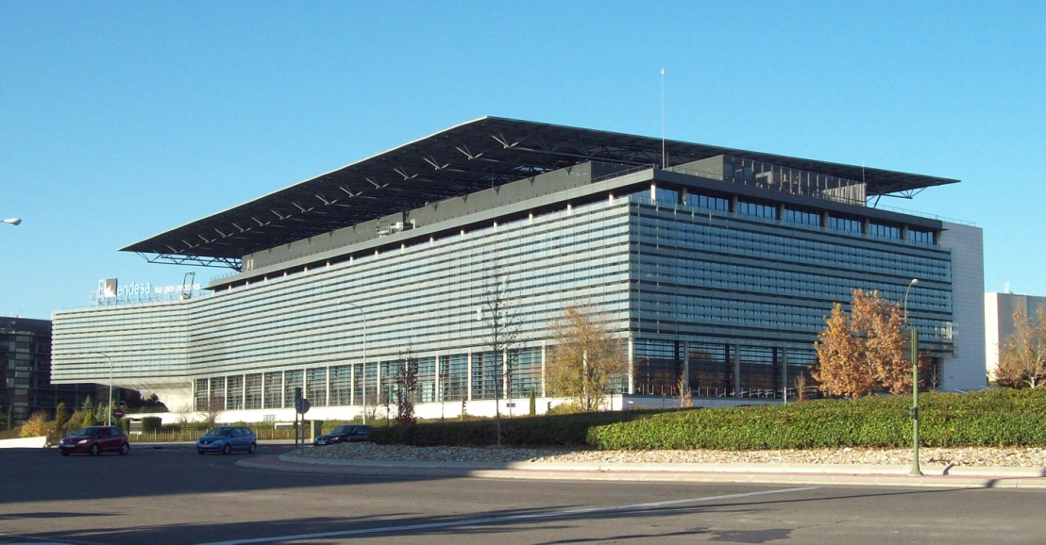

Endesa Headquarters, Madrid

JOHN E. FOSTER AND PARTNERS, LONDON

**Design Engineer**

Experience similar to Ross and Partners: Produced design calculations for a vast array of projects in steel, in-situ and precast concrete, timber and load bearing masonry. New build and renovations. Residential, commercial and office.

Preparation of structural surveys and appraisals of existing buildings, reports etc.

Projects included:

|  |  |
| --- | --- |
| **3no. Multi-storey apartments, London** | Client: Albany Homes |
| **Multi-storey apartments, Kensington, London** | Client: LCR Developments |
| **Harrow Weald Nursing Home** | Client: Bell & Webster |
| **Refurbishment 10 storey concrete frame, City Road, London** | Client: Crocker Group |
| **Refurbishment Canada Wharf, Rotherhithe, London** | Client: Crocker Group |

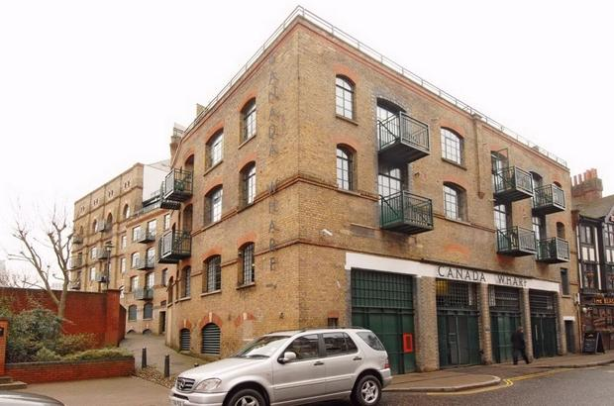

Canada Wharf

**Resident Engineer** Roebuck House, Victoria

Extensive repairs and replacement of concrete façade to 16 storey concrete framed residential block in central London.

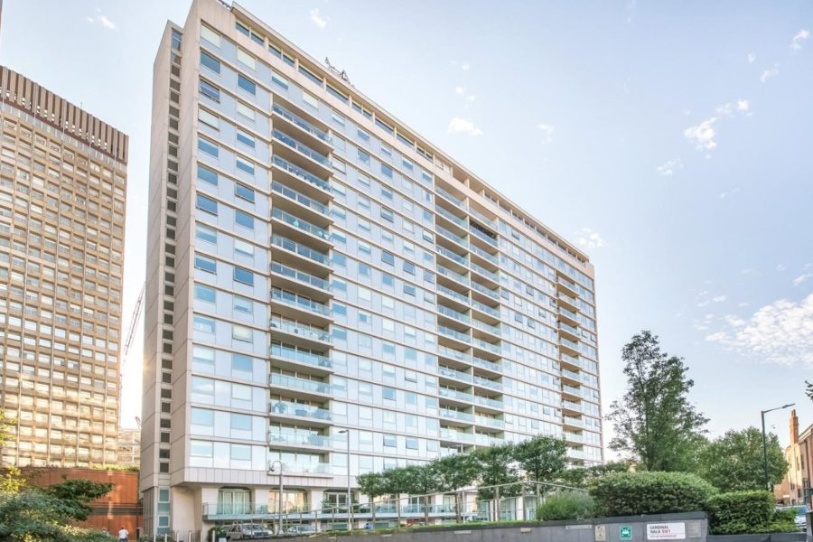

Roebuck House